Apply filters to SQL queries

Project description
In this scenario, I am a security professional at a large organization, and my job is to investigate security issues to help keep the system secure. Recently, we discovered some potential security issues that involve login attempts and employee machines. My task was to examine the organization’s data in their employees and log_in_attempts tables, and use SQL filters to retrieve records from different datasets and investigate the potential security issues.

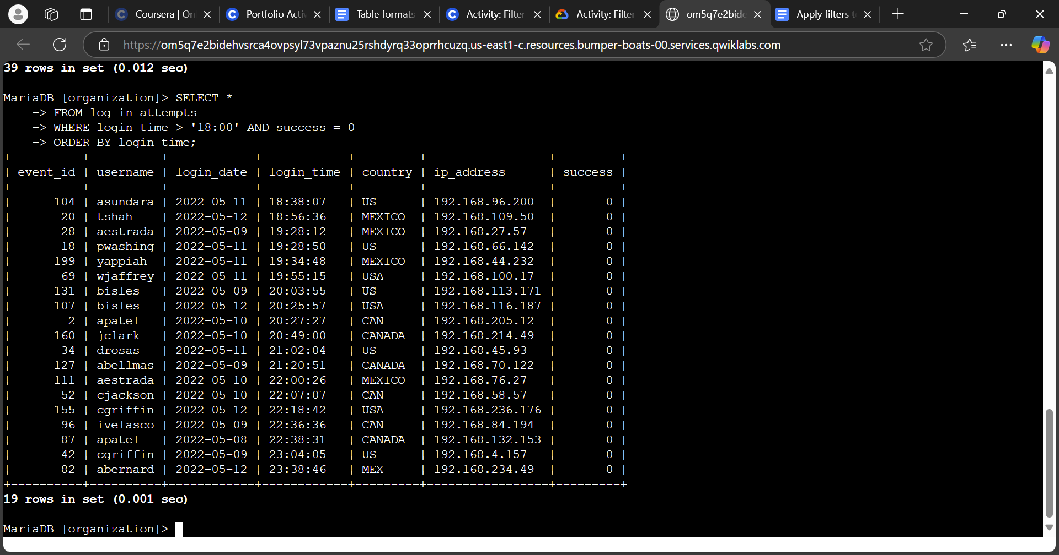
Retrieve after hours failed login attempts
For my first task, I had to investigate a potential security incident that may have happened after business hours, which was 6:00 PM or 18:00. I went on to SQL or MariaDB to query the log_in_attempts table to review after hours login activity. I did this by querying:
SELECT *
FROM log_in_attempts
WHERE login_time > ‘18:00’ AND success = 0
ORDER BY login_time;
To break down the query, SELECT * asks for an output of all of the columns in the data table, where FROM log_in_attempts specifies which table the data is being pulled from, which is log_in_attempts. Then, WHERE login_time > ‘18:00’ AND success = 0 asks what data to filter from the columns in the table. In this instance, I wanted to filter out login times that were after 18:00, indicated by login_time > ‘18:00’ and also login attempts that failed, indicated by success = 0. Since the data in success has boolean values, which are based on true or false values, where ‘1’ is true and ‘0’ is false, I made sure to also filter data that had both instances of login attempts that were after 18:00 and were unsuccessful in logging in. In addition, I took the liberty to add an ORDER BY login_time; line where it sorted the data by login times. This way, we can sort through the data through login times and see which times were suspicious login times after 18:00.

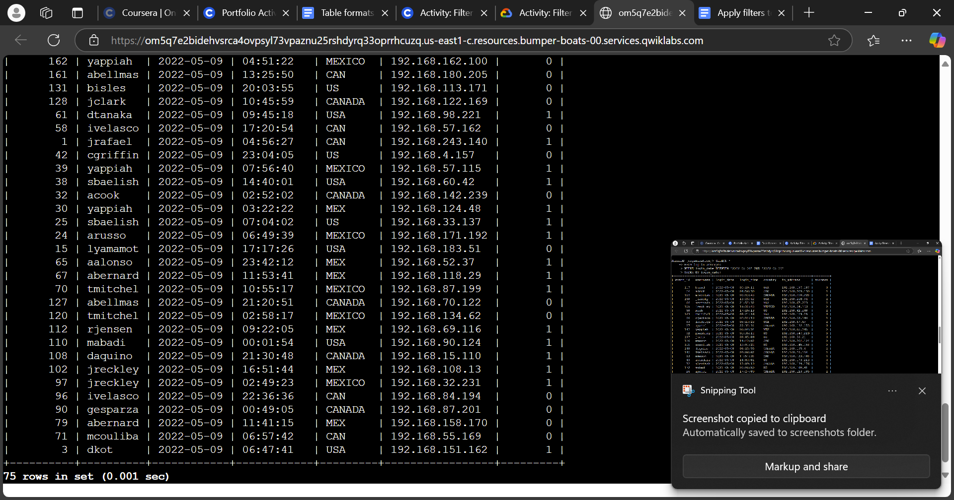
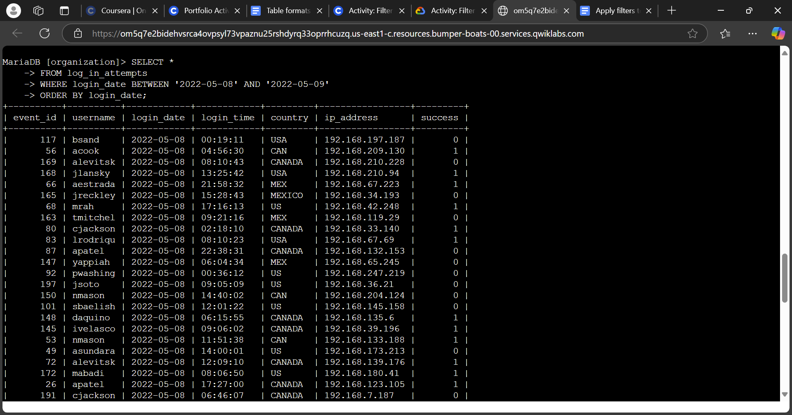
Retrieve login attempts on specific dates
Next, we discovered that a suspicious event occurred on May, 9, 2022. To investigate this event, I wanted to review all login attempts which occurred on that day and the day before. So I followed up on the query with the following:
SELECT *
FROM log_in_attempts
WHERE login_date BETWEEN ‘2022-05-08’ AND ‘2022-05-09’
ORDER BY login_date;
In order to output the data between the two dates, I inputted WHERE login_date BETWEEN ‘2022-05-08’ AND ‘2022-05-09’, which it told SQL to filter data that only had the dates between May 8, 2022 and May 9, 2022. This way, it outputs login attempts that only occurred within the two date ranges, making it easier to find the source of the suspicious event.

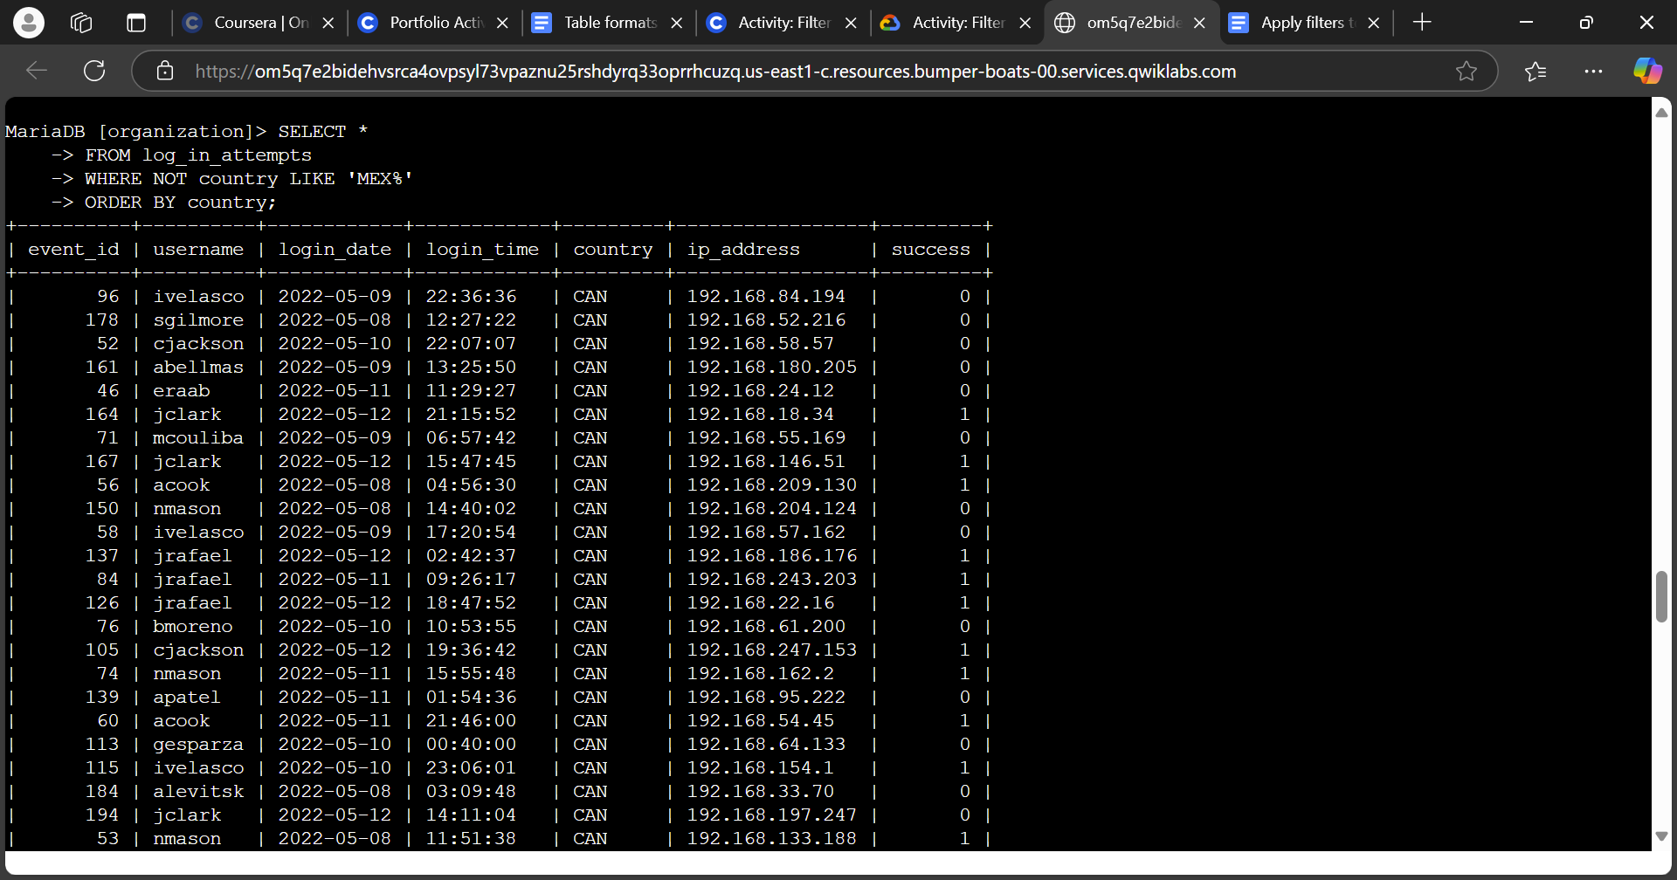
Retrieve login attempts outside of Mexico
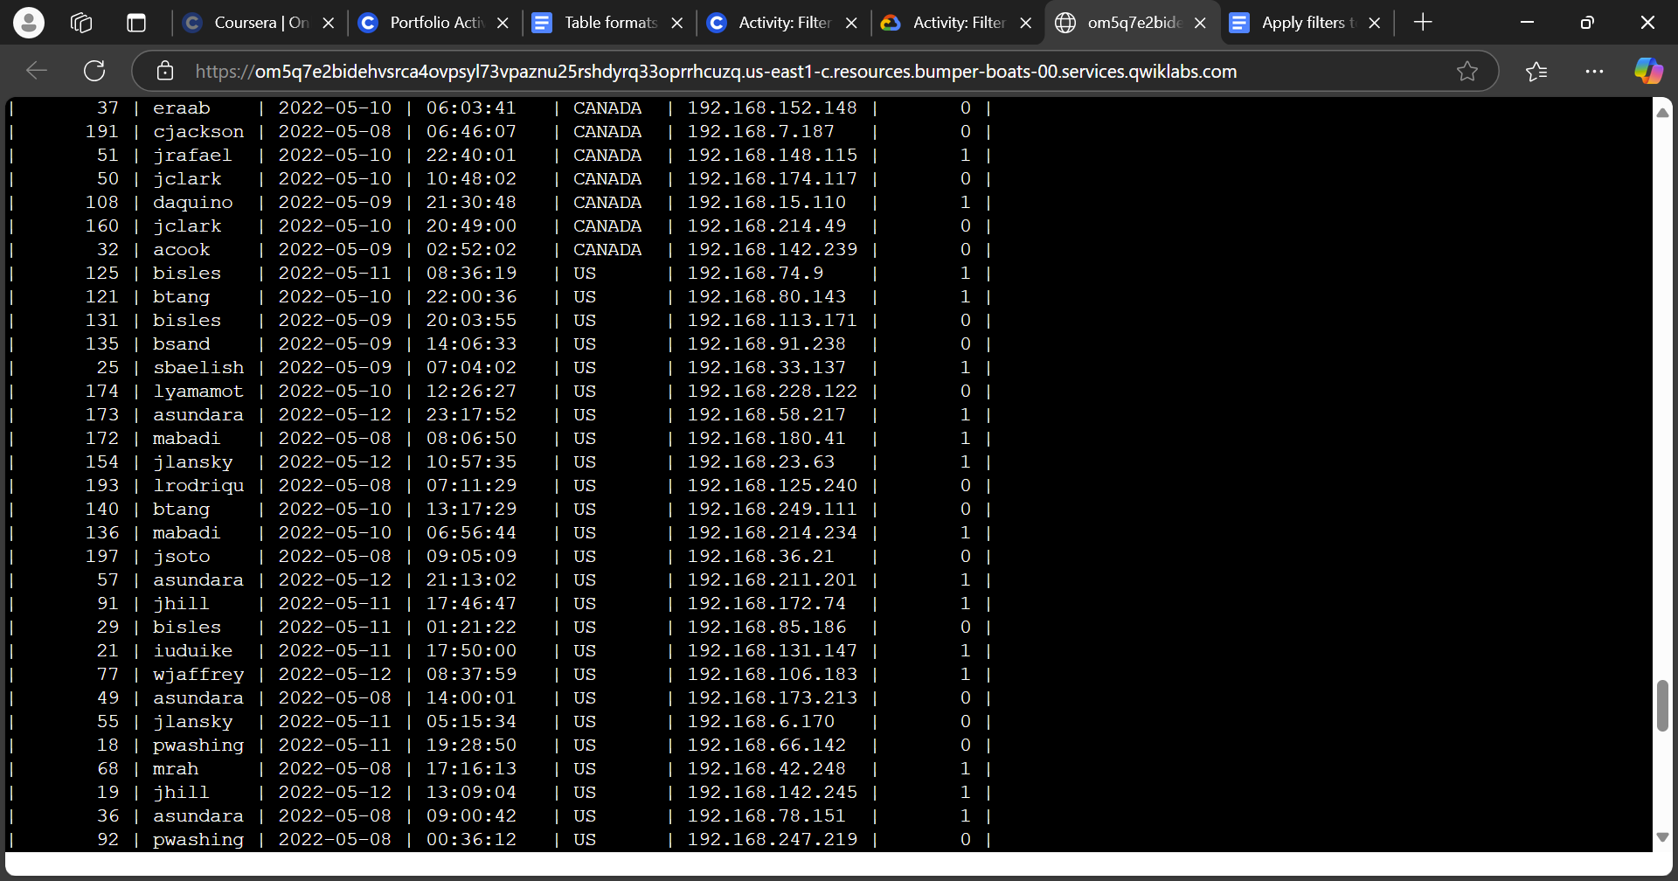
The security team followed up that suspicious activity did not occur with login attempts from Mexico. This makes it easier to filter out extraneous data points that can get us closer to the suspicious activity. In order to achieve this, I followed up the query with:
SELECT *
FROM log_in_attempts
WHERE NOT country LIKE ‘MEX%’
ORDER BY country;
This time, I input WHERE NOT country LIKE ‘MEX%’ to tell SQL to filter out data points that contain the string ‘MEX%’. I then used the LIKE operator to search for a pattern in the country column, which in this case, is finding strings that contain “MEX”, with the % substitutes any other characters that follow “MEX”. Since the country “Mexico” in the data table may also include abbreviations like “MEX”, this ensures that it will filter out all of the data with “MEX” or “Mexico” in the country column. In addition, since we do not want data points with “MEX” to be outputted, the NOT operator tells SQL to not output data that contains the strings ‘MEX%’. As you can see above, I sorted the data points by country to check that no data points from Mexico were included in the output. And where there should be data points of Mexico between Canada and the US, there were no data points, successfully outputting only data points that do not contain Mexico in the country column.

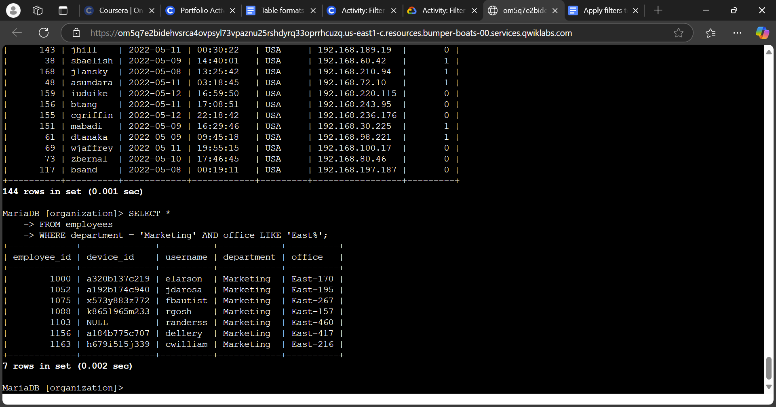
Retrieve employees in Marketing
Because of the suspicious activity, our security team wanted to perform security updates on specific employee machines in the Marketing department in the East office of the organization. I had queried the following to find the list of employees in their employees data table:
SELECT *
FROM employees
WHERE department = ‘Marketing’ AND office LIKE ‘East%’;
This query allowed me to filter employees in the data table, those that worked in the Marketing department, and also those that worked in the East office. I used office LIKE ‘East%’ as a way to filter office location, as the office is a primary key column with different office numbers. In order to find individuals in the East location, I added the ‘East%’ to indicate data points that contained employees working in the East location, regardless of what number they are in.

Retrieve employees in Finance or Sales
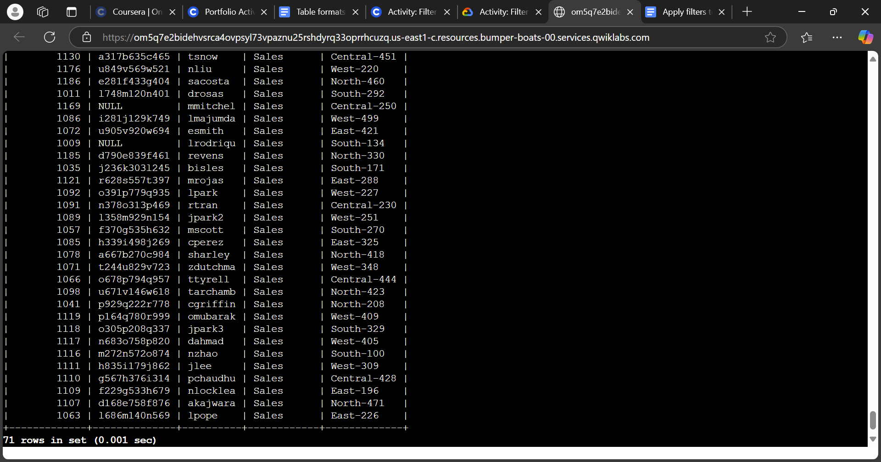
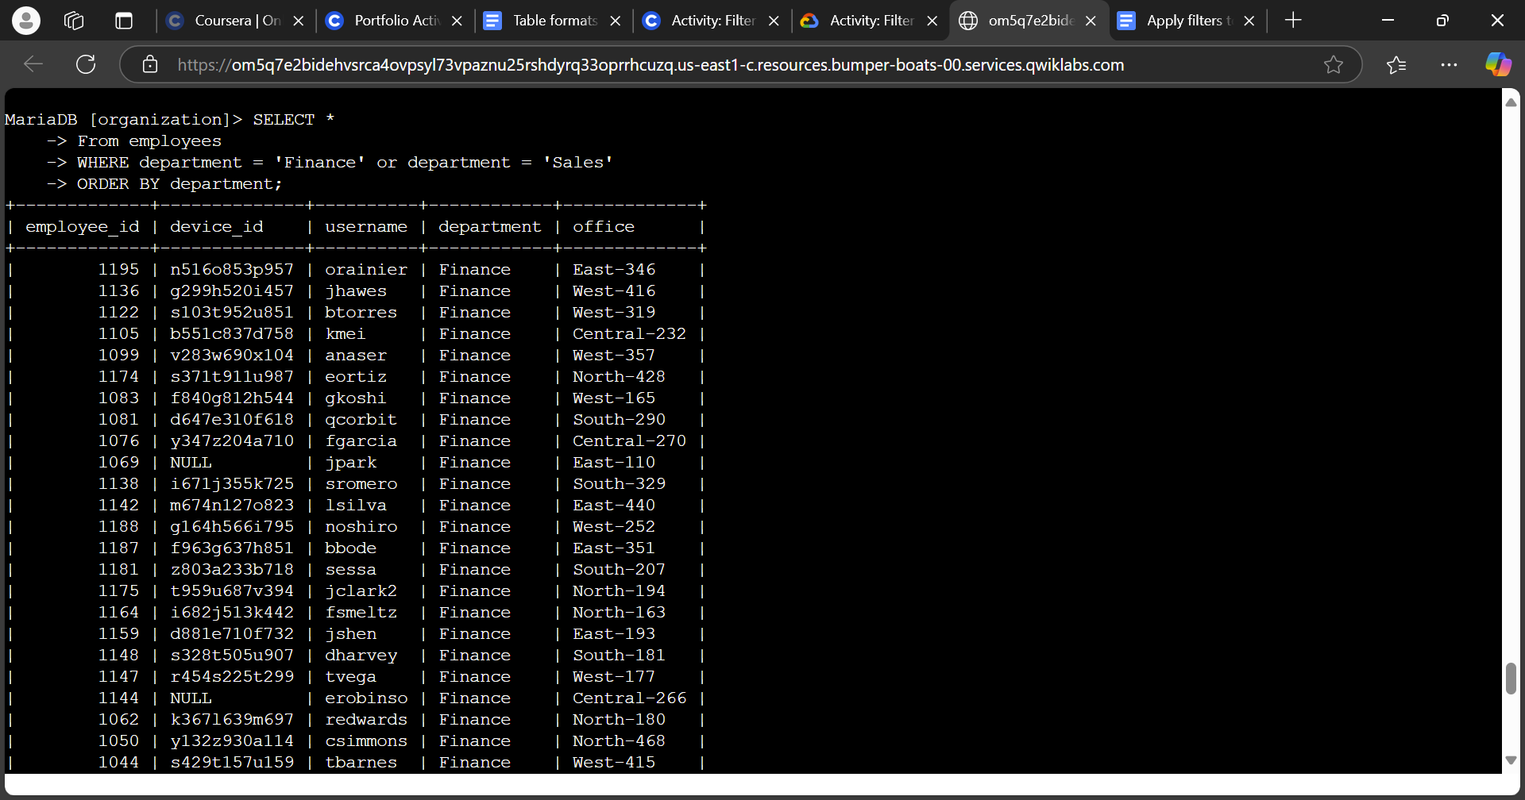
The security team then needed to perform a different security update on machines for employees in the Sales or Finance departments of the organization. The query I used to achieve the output above was:
SELECT *
FROM employees
WHERE department = ‘Finance’ OR department = ‘Sales’
ORDER BY department;
This allowed the output from SQL to show both instances of the Sales or Finance department. I wanted to show the employees from either department, but not employees who work in both departments, which is why I used the OR operator rather than AND. I also used ORDER BY department; to ensure that it only filtered out those employees working in the Finance or Sales department, which is shown above.

Retrieve all employees not in IT
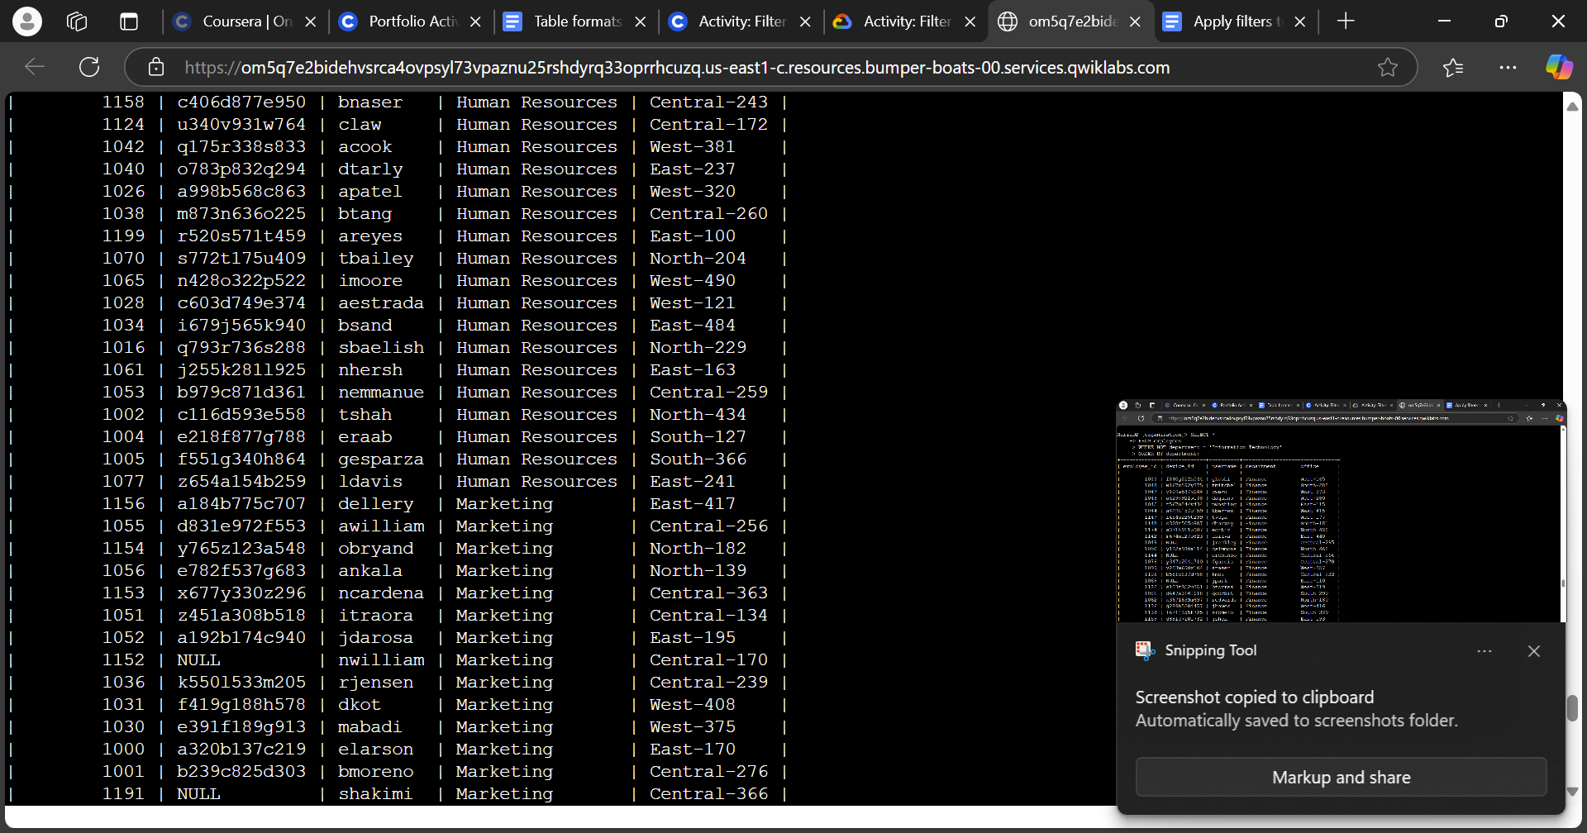
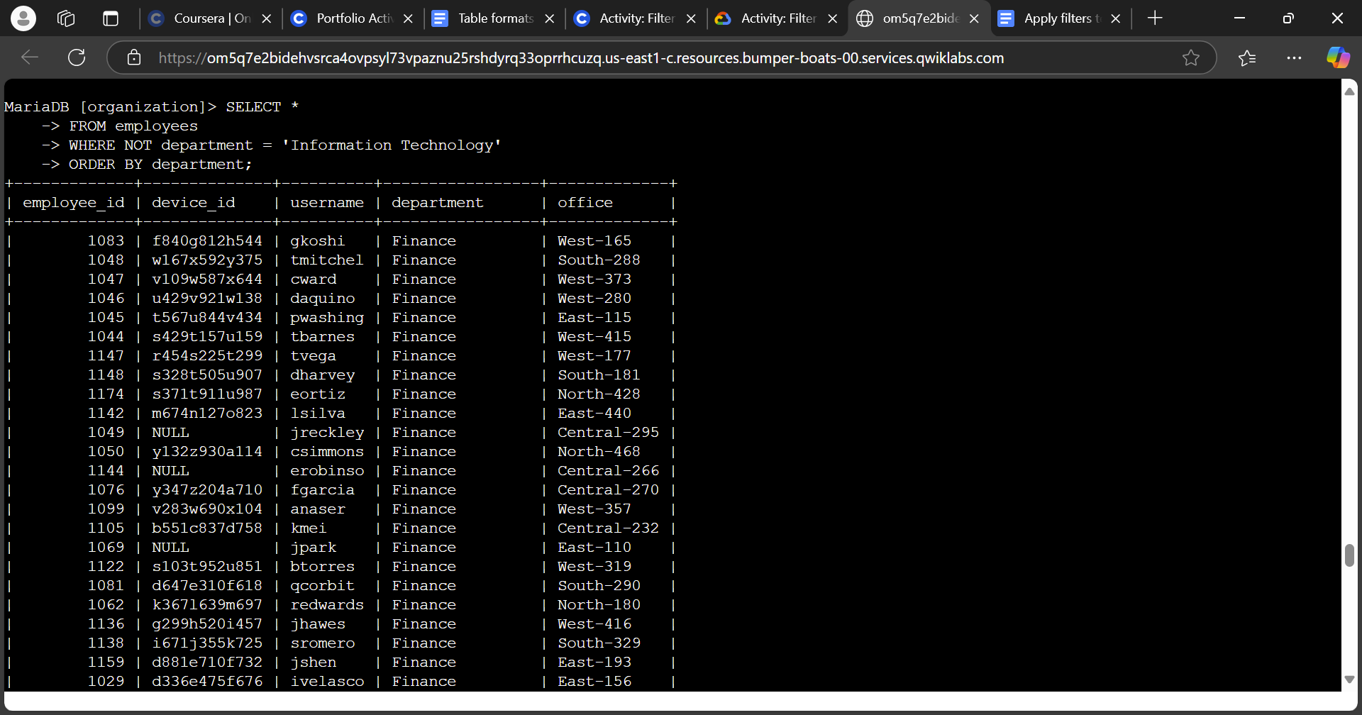
Lastly, my security team needs to make one more update to employee machines. The employees who are in the Information Technology department already had this update, but employees in all other departments need it. I did another query with the following:
SELECT *
FROM employees
WHERE NOT department = ‘Information Technology’
ORDER BY department;
This allowed SQL to output employees that are outside of the Information Technology department of the organization and sort the employees by department to ensure no employee from the IT department was included in the output. This allowed for the security team to see who from which department needed to update their computers and get it facilitated efficiently.

Summary
I utilized SQL to query data by using AND, OR, and NOT, to specify filters for outputting data that is only needed from certain columns. From investigating the log_in_attempts table to find login attempts that were suspicious and filter out criteria that are not relevant to the investigation, to querying the employees table to find employees within the organization for security updates. Using SQL was a powerful tool in getting things facilitated with sorting data, and using the AND, OR, and NOT operations helped to make SQL more efficient in sorting necessary data relevant to what were needing.

